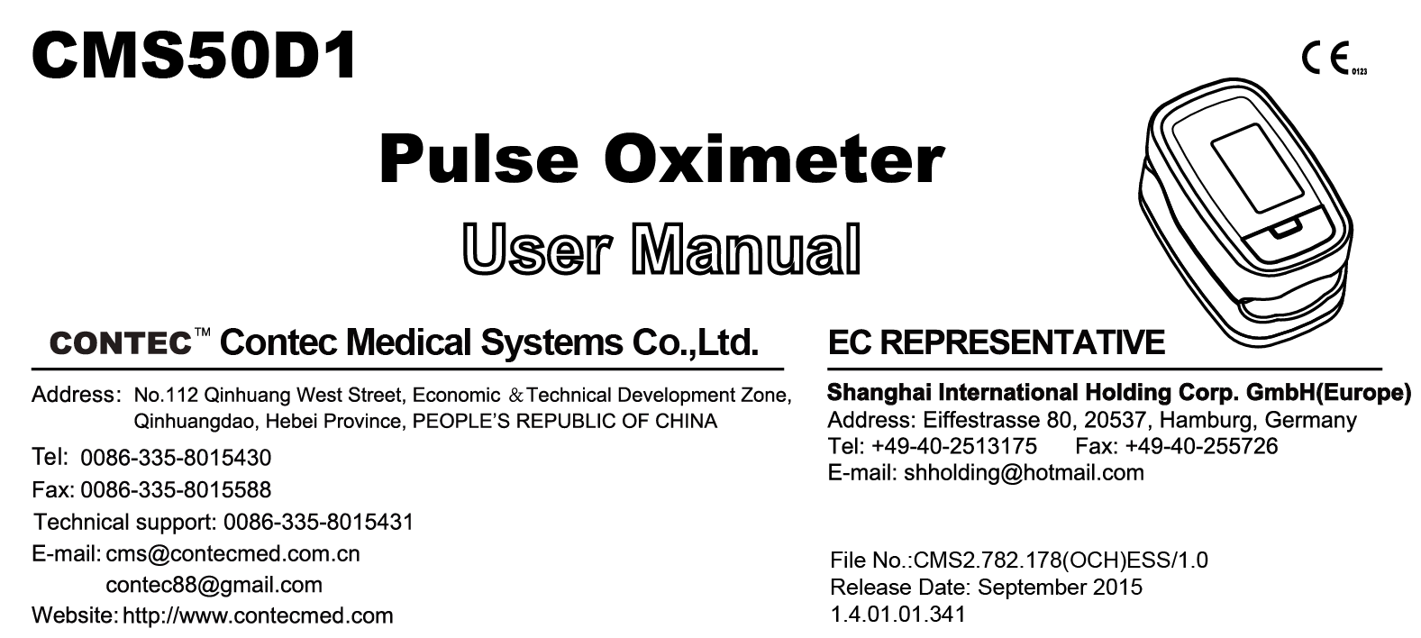
Instructions to User
Dear Users, thank you very much for purchasing our product.
In case of modifications and software upgrades, the information contained in this document is subject to change without notice.
The Manual describes, in accordance with the Pulse Oximeter’s features and requirements, main structure, functions, specifications, correct methods for transportation, installation, usage, operation, repair, maintenance and storage, etc. as well as the safety procedures to protect both the user and equipment. Refer to the respective chapters for details.
Please read the Manual very carefully before using this equipment. These instructions describe the operating procedures to be followed strictly, failure to follow these instructions can cause measuring abnormality, equipment damage and personal injury. The manufacturer is NOT responsible for the safety, reliability and performance issues and any monitoring abnormality, personal injury and equipment damage due to user’s negligence of the operation instructions. The manufacturer’s warranty service does not cover such faults.
Owing to the forthcoming renovation, the specific products you received may not be totally in accordance with the description of this User Manual. We would sincerely regret for that.
This product can be used repeatedly. Its using life is 3 years.
If you have any questions regarding to the use of this product, please call us at 1-847-562-1702 Monday-Friday from 8:00 AM to 5:00 PM Eastern Time.
WARNING:
- The uncomfortable or painful feeling may appear if using the device ceaselessly, especially for the microcirculation barrier users. It is recommended that the sensor should not be applied to the same finger for over 2 hours.
- For the individual users, there should be a more prudent inspecting in the placing process. The device can not be clipped on the edema and tender tissue.
- The light (the infrared is invisible) emitted from the device is harmful to the eyes, so the user and the maintenance man, can not stare at the light.
- User can not use enamel or other makeup.
- User’s fingernail can not be too long.
- Please peruse the relative content about the clinical restrictions and caution.
- This device is not intended for treatment.
The User Manual is published by our company. All rights reserved.

1 Safety

1.1 Instructions for Safe Operations
- Check the main unit and all accessories periodically to make sure that there is no visible damage that may affect user’s safety and monitoring performance about cables and transducers. It is recommended that the device should be inspected once a week at least. When there is obvious damage, stop using the oximeter.
- Necessary maintenance must be performed by qualified service engineers ONLY. Users are not permitted to maintain it by themselves.
- The oximeter cannot be used together with devices not specified in User’s Manual. Only the accessory that appointed or recommendatory by manufacture can be used with this device.
- This product is calibrated before leaving factory.

1.2 Warnings
- Explosive hazard—DO NOT use the oximeter in environment with inflammable gas such as some ignitable anesthetic agents.
- The person who is allergic to rubber can not use this device.
- The disposal of scrap instrument and its accessories and packings(including battery, plastic bags, foams and paper boxes) should follow the local laws and regulations.
- Please check the packing before use to make sure the device and accessories are totally in accordance with the packing list, or else the device may have the possibility of working abnormally.
- Please don't measure this device with function test paper for the device's related information.
- Part of the device that are not serviced or maintained while in use with the user.
- Warning against servicing and maintenance while the equipment is in use.
- No modification of this equipment is allowed.
- The user is an intended operator.
- The probe of the device is the applied part.

1.3 Attentions
    - Keep the oximeter away from dust, vibration, corrosive substances, explosive materials, high temperature and moisture.
    - If the oximeter gets wet, please stop operating it.
    - When it is carried from cold environment to warm or humid environment, please do not use it immediately.
    - DO NOT operate keys on front panel with sharp materials.
    - High temperature or high pressure steam disinfection of the oximeter is not permitted. Refer to User Manual in the relative chapter (7.1)for instructions of cleaning and disinfection.
    - Do not have the oximeter immerged in liquid. When it needs cleaning, please wipe its surface with medical alcohol by soft material. Do not spray any liquid on the device directly.
    - When cleaning the device with water, the temperature should be lower than 60℃.
    - As to the fingers which are too thin or too cold, it would probably affect the normal measure of the users' SpO2 and pulse rate, please clip the thick finger such as thumb and middle finger deeply enough into the probe.
    - Do not use the device on infant or neonatal users.
    - The product is suitable for adults(Weight should be between 40kg to 110kg).
    - The device may not work for all users. If you are unable to achieve stable readings, discontinue use.
    - The update period of data is less than 5 seconds, which is changeable according to different individual pulse rate.
    - The waveform is normalized.Please read the measured value when the waveform on screen is equably and steady-going, Here this measured value is optimal value. And the waveform at the moment is the standard one.
    - If some abnormal conditions appear on the screen during test process, pull out the finger and reinsert to restore normal use.
    - The hanging rope attached the product is made from Non- allergy material, if particular group are sensitive to the hanging rope, stop using it. In addition, pay attention to the use of the hanging rope , do not wear it around the neck avoiding cause harm to the users.
    - The instrument dose not have low-voltage alarm function, it only shows the low-voltage, please change the battery when the battery energy is used out.
    - When the parameter is particularly, The instrument dose not have alarm function. Do not use the device in situations where alarms are required.
    - Batteries must be removed if the device is going to be stored for more than one month, or else batteries may leak.
    - A flexible circuit connects the two parts of the device. Do not twist or pull on the connection.

1.4.Indication for Use
The Pulse Oximeter is a non-invasive device intended for the spot-check of saturation of arterial hemoglobin(SpO2) and the pulse rate of adult in home use environments.This device is not intended for continuous monitoring.The device can be multi-used.Solely for use with sporting and aviation activities.Intended to monitor heart rate during exercise.

2 Overview
The pulse oxygen saturation is the percentage of HbO₂ in the total Hb in the blood, so-called the O₂ concentration in the blood. It is an important bio-parameter for the respiration. For the purpose of measuring the SpO₂ more easily and accurately, our company developed the Pulse Oximeter. At the same time, the device can measure the pulse rate simultaneously.
The Pulse Oximeter features in small volume, low power consumption, convenient operation and being portable. It is only necessary for user to put one of his fingers into a fingertip photoelectric sensor for diagnosis, and a display screen will directly show measured value of Hemoglobin Saturation..

2.1 Features
- Operation of the product is simple and convenient.
- The product is small in volume, light in weight (total weight is about 50g including batteries) and convenient in carrying.
- Power consumption of the product is low and the two originally equipped AAA batteries can be operated continuously for 20 hours.
- The product will automatically be powered off when no signal is in the product within 5 seconds.
- 4 directions display mode without waveform.
- Waveform display mode as line drawing or filling manner.

2.2 Major Applications and Scope of Application
The Pulse Oximeter can be used in measuring pulse oxygen saturation and pulse rate through finger. The product is suitable for family use(It can be used before or after doing sports, and it is not recommended to use the device during the process of doing sports) .
 The problem of overrating would emerge when the user is suffering from toxicosis which caused by carbon monoxide, the device is not recommended to be used under this circumstance.

2.3 Environment Requirements
Storage Environment
a) Temperature :-40℃~+60℃
b) Relative humidity :≤95%
c) Atmospheric pressure :500hPa~1060hPa
Operating Environment
a) Temperature:10℃~40℃
b) Relative Humidity :≤75%
c) Atmospheric pressure:700hPa~1060hPa

3 Principle and Caution

3.1 Principle of Measurement
Principle of the Oximeter is as follows: An experience formula of data process is established taking use of Lambert Beer Law according to Spectrum Absorption Characteristics of Reductive Hemoglobin (Hb) and Oxyhemoglobin (HbO₂) in glow & near-infrared zones. Operation principle of the instrument is: Photoelectric Oxyhemoglobin Inspection Technology is adopted in accordance with Capacity Pulse Scanning & Recording Technology, so that two beams of different wavelength of lights can be focused onto human nail tip through perspective clamp finger-type sensor. Then measured signal can be obtained by a photosensitive element, information acquired through which will be shown on screen through treatment in electronic circuits and microprocessor.
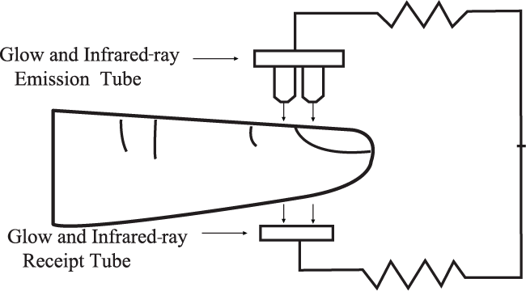
Figure 1. Operating Principle

3.2 Caution
- The finger should be placed properly (see the attached illustration of this manual ,Figure 7), or else it may cause inaccurate measurement.
- The SpO₂ sensor and photoelectric receiving tube should be arranged in a way with the subject’s arteriole in a position there between.
- The SpO₂ sensor should not be used at a location or limb tied with arterial canal or blood pressure cuff or receiving intravenous injection.
- Make sure the optical path is free from any optical obstacles like rubberized fabric.
- Excessive ambient light may affect the measuring result. It includes fluorescent lamp, dual ruby light, infrared heater, direct sunlight and etc.
- Strenuous action of the subject or extreme electrosurgical interference may also affect the accuracy.
- User can not use enamel or other makeup.

3.3 Clinical Restrictions
- As the measure is taken on the basis of arteriole pulse, substantial pulsating blood flow of subject is required. For a subject with weak pulse due to shock, low ambient/body temperature, major bleeding, or use of vascular contracting drug, the SpO₂ waveform (PLETH) will decrease. In this case, the measurement will be more sensitive to interference.
- For those with a substantial amount of staining dilution drug (such as methylene blue, indigo green and acid indigo blue), or carbon monoxide hemoglobin (COHb), or methionine (Me+Hb) or thiosalicylic hemoglobin, and some with icterus problem, the SpO₂ determination by this monitor may be inaccurate.
- The drugs like dopamine, procaine, prilocaine, lidocaine and butacaine may also be a major factor blamed for serious error of SpO₂ measure.
- As the SpO₂ value serves as a reference value for judgement of anemic anoxia and toxic anoxia, some users with serious anemia may also report good SpO₂ measurement.

4 Technical Specifications
1. Display Format: OLED Display;
SpO₂ Measuring Range: 0% - 100%;
Pulse Rate Measuring Range: 30 bpm - 250 bpm;
Pulse Wave Display: bar-graph display and the waveform display.
2. Power Requirements: 2 ×1.5V AAA alkaline battery(or use the rechargeable battery instead), adaptable range: 2.6V-3.6V.
3. Power Consumption: Smaller than 30mA.
4. Resolution: 1% for SpO₂ and 1 bpm for Pulse Rate.
5. Measurement Accuracy: ±2% in stage of 70%-100% SpO₂, and meaningless when stage being smaller than 70%. ±2 bpm or±2% (select larger) for Pulse Rate. Clinical Trial :SpO₂ regression plot & Bland–Altman plot,Refer to Figure 2 & Figure 3.
6. Measurement Performance in Weak Filling Condition: SpO₂ and pulse rate can be shown correctly when pulse-filling ratio is 0.4%. SpO₂ error is ±4%, pulse rate error is ±2 bpm or ±2% (select larger).
7. Resistance to surrounding light: The deviation between the value measured in the condition of man-made light, indoor natural light and darkroom is less than ±1%.
8. It is equipped with a switch function. The Oximeter can be powered off when the finger is off the oximeter within 5 seconds.
9. Optical Sensor
Red light (wavelength is 660nm, 6.65mW)
Infrared (wavelength is 880nm, 6.75mW)
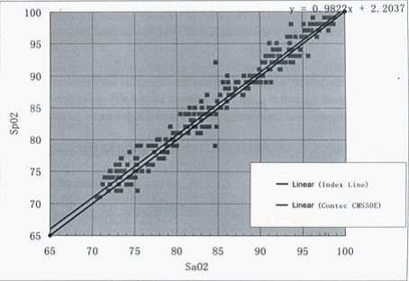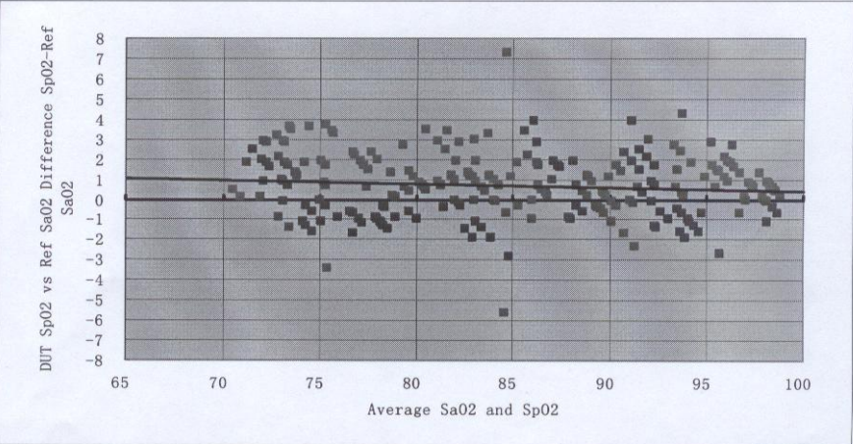
Figure 2 SpO₂ regression plot Figure 3 Bland–Altman plot

5 Accessories
- One hanging rope;
- Two batteries (optional);
- One User Manual.

6 Installation

6.1 View of the Front Panel
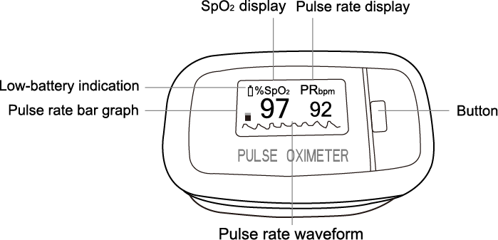
Figure 4. Front View

6.2 Battery
Step 1. Refer to Figure 5. and insert the two AAA size batteries properly in the right direction.
Step 2. Put back the cover.
Please take care when you insert the batteries for the improper insertion may damage the device.
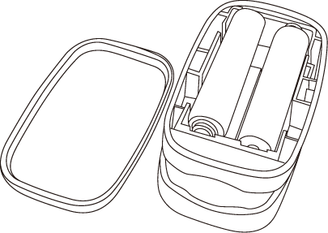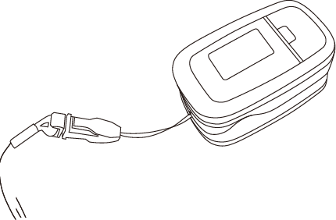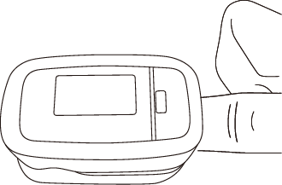
Figure 5. Batteries Installation Figure 6. Mounting the hanging rope Figure 7. Put finger in position

6.3 Mounting the Hanging Rope
Step 1. Put the end of the rope through the hole.
Step 2. Put another end of the rope through the first one and then tighten it.

7 Operating Guide
7.1 Insert the two batteries properly to the direction, and then replace the cover.
7.2 Open the clip as shown in Figure 7.
7.3 Let the user’s finger put into the rubber cushions of the clip (make sure the finger is in the right position), and then clip the finger.
7.4 Press the switch button once on front panel.
7.5 Do not shake the finger and keep the user at ease during the process. Meanwhile, human body is not recommended in movement status.
7.6 Get the information directly from screen display.
7.7 The button has three functions.When the device is power off, pressing the button can open it; When the device is power on, pressing the button shortly can change direction of the screen; When the device is power on, pressing the button long can change brightness of the screen.
Press the button shortly when the device is power on, the display mode will change, show as follow figure:

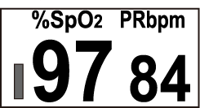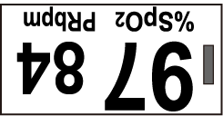
Figure 8 Display mode one Figure 9 Display mode two
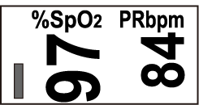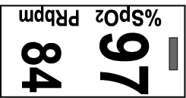
Figure 10 Display mode three Figure 11 Display mode four
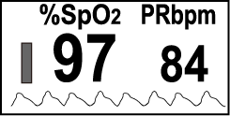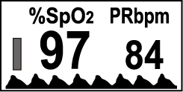
Figure 12 Display mode five Figure 13 Display mode six
Fingernails and the luminescent tube should be on the same side.

8 Repairing and Maintenance
- Please change the batteries when the low-voltage displayed on the screen.
- Please clean the surface of the device before using. Wipe the device with medical alcohol first, and then let it dry in air or clean it by dry clean fabric.
- Using the medical alcohol to disinfect the product after use, prevent from cross infection for next time use.
- Please take out the batteries if the oximeter is not in use for a long time.
- The packed device can be transported by ordinary conveyance or according to transport contract.The device can not be transported mixed with toxic, harmful, corrosive material.
- The best storage environment of the device is - 40ºC to 60ºC ambient temperature and not higher than 95% relative humidity.
- Users are advised to calibrate the device termly (or according to the calibrating program of hospital). It also can be performed at the state-appointed agent or just contact us for calibration.
High-pressure sterilization cannot be used on the device.
Do not immerse the device in liquid.
It is recommended that the device should be kept in a dry environment. Humidity may reduce the useful life of the device, or even damage it.

9 Troubleshooting
Trouble | Possible Reason | Solution
The SpO₂ and Pulse Rate can not be displayed normally | 1. The finger is not properly positioned.  2. The user’s SpO₂ is too low to be detected. | 1. Place the finger properly and try again.  2. Try again; Go to a hospital for a diagnosis if you are sure the device works all right.
The SpO₂ and Pulse Rate are not displayed stably | - The finger is not placed inside deep enough.  - The finger is shaking or the user is moving. | 1. Place the finger properly and try again.  2. Let the user keep calm
The device can not be turned on | 1. The batteries are drained or almost drained.  2. The batteries are not inserted properly.  3. The malfunction of the device. | 1. Change batteries.  2. Reinstall batteries.  3. Please contact the local service center.
The display is off suddenly | 1. The device will power off automatically when it gets no signal within 5 seconds.  2. The batteries are almost drained. | 1. Normal.  2. Change batteries.

10 Key of Symbols
Symbol | Description
 | Type BF
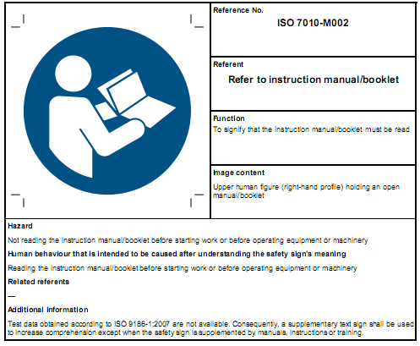 | Refer to instruction manual/booklet
 | The pulse oxygen saturation(%)
PRbpm | Pulse rate (bpm)
 | The battery voltage indication is deficient (change the battery in time avoiding the inexact measure)
1. no finger inserted
2. An indicator of signal inadequacy
 | Battery positive electrode
 | battery negative electrode；
- Power switch
- change direction of the screen
- Change brightness of the screen
SN | Serial number
 | Alarm inhibit
 | WEEE (2002/96/EC)
IP22 | Ingress of liquids rank
 | European Representative
 | This item is compliant with Medical Device Directive 93/42/EEC of June 14, 1993, a directive of the European Economic Community.
 | Manufacturer
 | Manufacture Date
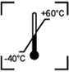 | Storage and Transport Temperature limitation
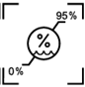 | Storage and Transport Humidity limitation
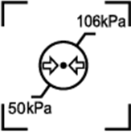 | Storage and Transport Atmospheric pressure limitation
 | This side UP
 | Fragile, handle with care
 | Keep dry
 | Recyclable

11 Function Specification
Display Information | Display Mode
The Pulse Oxygen Saturation(SpO₂) | OLED
Pulse Rate(PR) | OLED
Pulse Intensity (bar-graph) | OLED bar-graph display
Pulse wave | OLED
SpO₂ Parameter Specification
Measuring range | 0%~100%, (the resolution is 1%).
Accuracy | 70%~100%: ±2% ,Below 70% unspecified.
Optical Sensor | Red light (wavelength is 660nm)  Infrared (wavelength is 880nm)
Pulse Parameter Specification
Measuring range | 30bpm~250bpm (the resolution is 1 bpm)
Accuracy | ±2bpm or±2% select larger
Pulse Intensity
Range | Continuous bar-graph display, the higher display indicate the stronger pulse.
Battery Requirement
1.5V (AAA size) alkaline batteries × 2 or rechargeable battery
Battery Useful Life
Two batteries can work continually for 20 hours
Dimensions and Weight
Dimensions | 61(L) × 36(W) × 32(H) mm
Weight | About 57g (with the batteries)

Appendix
Guidance and manufacture’s declaration-electromagnetic emission
for all EQUIPMENT and SYSTEMS
Guidance and manufacture’s declaration –electromagnetic emission
The CMS50D1 Pulse Oximeter is tended for use in the electromagnetic environment specified below. The customer of the user of the CMS50D1 Pulse Oximeter should assure that it isused in such an environment.
Emission test | compliance | Electromagnetic environment-guidance
RF emissions  CISPR 11 | Group 1 | The CMS50D1 Pulse Oximeter uses RF energy only for their internal function. Therefore, its RF emissions are very low and are not likely to cause any interference in nearby electronic equipment.
RF emissions  CISPR 11 | Class B | The CMS50D1 Pulse Oximeter is suitable for use in all establishments,including domestic establishments and those directly connected to the public low-voltage power supply network that supplies buildings used for domestic purposes.
Harmonic emissions  IEC 61000-3-2 | Not applicable
Voltage fluctuations/  flicker emission  IEC 61000-3-3 | Not applicable

Guidance and manufacture’s declaration-electromagnetic immunity
for all EQUIPMENT and SYSTEMS
Guidance and manufacture’s declaration-electromagnetic immunity
The CMS50D1 Pulse Oximeter is intended for use in the electromagnetic environment specified specified below. The the user of CMS50D1 Pulse Oximeter should assure that it is used in such an environment.
Immunity test | IEC60601 test level | Compliance level | Electromagnetic environment-guidance
Electrostatic discharge (ESD) IEC 61000-4-2 | ±6KV contact  ±8KV air | ±6KV contact  ±8KV air | Floors should be wood, concrete or ceramic tile. If floor are covered with synthetic material, the relative humidity should be at least 30%.
Power frequency (50Hz) magnetic field  IEC 61000-4-8 | 3A/m | 3A/m | Power frequency magnetic fields should be at levels characteristic of a typical location in a typical commercial or hospital environment

Guidance and manufacture’s declaration-electromagnetic immunity
for EQUIPMENT and SYSTEMS that are not LIFE-SUPPORTING
Guidance and manufacture’s declaration-electromagnetic immunity
The CMS50D1 Pulse Oximeter is intended for use in the electromagnetic environment specified below. The customer or the user of CMS50D1 Pulse Oximeter should assure that it is used in such an environment.
Immunity test | IEC60601 test level | Compliance level | Electromagnetic environment -guidance
Radiated RF  ICE 61000-4-3 | 3V/m  80MHz to 2.5GHz | 3V/m | Portable and mobile RF communication equipment should be used no closer to any part of the CMS50D1 Pulse Oximeter, including cables, than the recommended separation distance calculated from the equation applicable to the frequency of the transmitter.  recommended separation distance  $d=\left[\frac{3\text{.}5}{E_{1}}\right]\sqrt{P}$ 80MHz to 800MHz  $d=\left[\frac{7}{E_{1}}\right]\sqrt{P}$ 800MHz to 2.5GHz  Where P is the maximum output power rating of the transmitter in watts (W) according to the transmitter manufacturer and d is the recommended separation distance in meters (m).  Field strengths from fixed RF transmitters, as determined by an electromagnetic site survey, ª should be less than the compliance level in each frequency range.^{b}  Interference may occur in the vicinity of equipment marked with the following symbol:  
NOTE 1 At 80MHz and 800MHz, the higher frequency range applies.
NOTE 2 These guidelines may not apply in all situations. Electromagnetic propagation is affected by absorption and reflection from structures, objects and people.
ª Field strengths from fixed transmitters, such as base stations for radio (cellular/cordless) telephones and land mobile radios, amateur radio, AM and FM radio broadcast and TV broadcastcannot be predicted theoretically with accuracy. To assess the electromagnetic environment due to fixed RF transmitters, an electromagnetic site survey should be considered. If the measured field strength in the location in which The CMS50D1 Pulse Oximeter is used exceeds the applicable RF compliance level above, the CMS50D1 Pulse Oximeter should be observed to verify normal operation. If abnormal performance is observed, additional measures may be necessary, such as reorienting or relocating the CMS50D1 Pulse Oximeter.
^{b} Over the frequency range 150 KHz to 80 MHz, field strengths should be less than 3V/m.

Recommended separation distances between portable and mobile
RF communications equipment and the EQUIPMENT or SYSTEM
for EQUIPMENT or SYSTEM that not LIFE-SUPPORTING

Recommended separation distances between
portable and mobile RF communications equipment and the CMS50D1 Pulse Oximeter
The CMS50D1 Pulse Oximeter is intended for use in the electromagnetic environment in which radiated RF disturbances are controlled. The customer or the user of the CMS50D1 Pulse Oximeter can help prevent electromagnetic interference by maintaining a minimum distance between portable and mobile RF communications equipment (transmitters) and the CMS50D1 Pulse Oximeter as recommended below, according to the maximum output power of the communications equipment.
Rated maximum output power of transmitter  (W) | Separation distance according to frequency of transmitter  (m)
Rated maximum output power of transmitter  (W) | 150KHz to 80MHz $d=\left[\frac{3\text{.}5}{E_{1}}\right]\sqrt{P}$ | 80MHz to 800MHz $d=\left[\frac{3\text{.}5}{E_{1}}\right]\sqrt{P}$ | 800MHz to 2.5GHz  $d=\left[\frac{7}{E_{1}}\right]\sqrt{P}$
0.01 | 0.12 | 0.12 | 0.23
0.1 | 0.37 | 0.37 | 0.74
1 | 1.17 | 1.17 | 2.33
10 | 3.69 | 3.69 | 7.38
100 | 11.67 | 11.67 | 23.33
For transmitters rated at a maximum output power not listed above, the recommended separation distanced in meters (m) can be estimated using the equation applicable to the frequency of the transmitter, where P is the maximum output power rating of the transmitter in watts (W) according to the transmitter manufacturer.
NOTE 1 At 80MHz and 800MHz, the separation distance for the higher frequency range applies.
NOTE 2 These guidelines may not apply in all situations. Electromagnetic propagation is affected by absorption and reflection from structures, objects and people.

